**Kubernetes Multi-Tenant Project**

**Step 1:** Check if Any Worker Node is Ready.

Run the following command to check the status of worker nodes:



**Step 2:** Install Calico for Networking.

Apply the Calico manifest to enable networking:

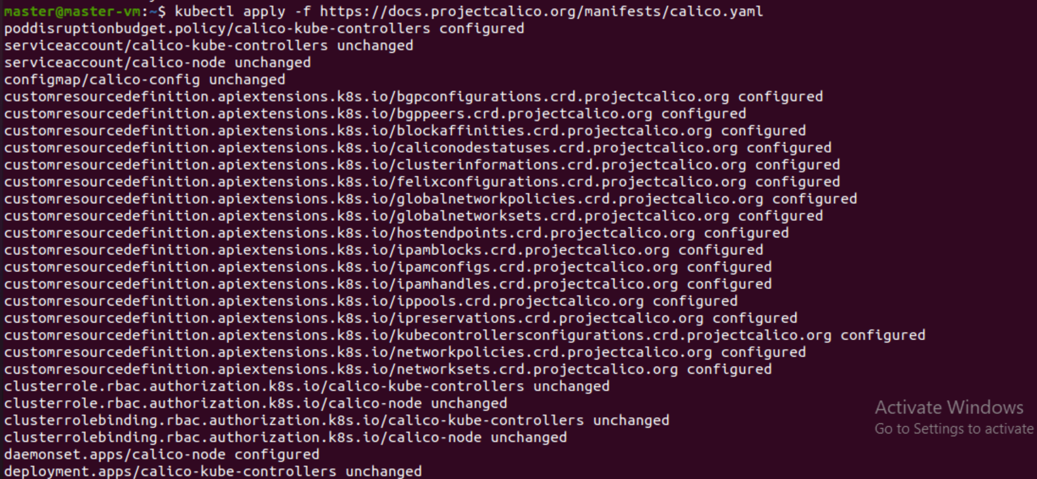

**Step 3:** Create Namespaces for Tenants.

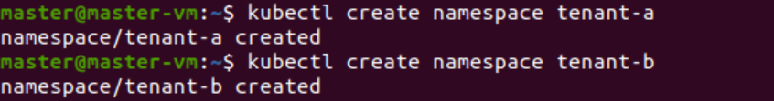

**Step 4:** Create Folder Structure for YAML Files**.**

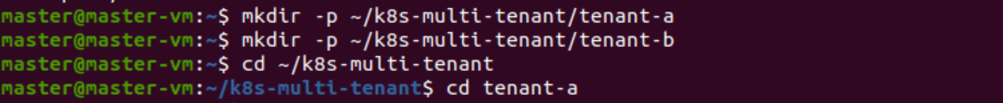

**Step 5:** Create Deployment and Service for Tenant A.



Apply the configuration:



**Step 6:** Restrict Network Access for Tenant A.



**Step 7:** Create Deployment and Service for Tenant B.



Apply the deployment:



**Step 8:** Restrict Network Access for Tenant B.



Apply the network policy:



**Step 9:** Verify Network Policy.



**Step 10:** Final Folder Structure.

The final folder structure should look like this:

k8s-multi-tenant/

│── tenant-a/

│ ├── tenant-a-app.yaml

│ ├── tenant-a-restrict.yaml

│── tenant-b/

│ ├── tenant-b-app.yaml

│ ├── tenant-b-restrict.yaml

**Step 11**: Test Tenant Isolation.

Create a test pod in tenant-b and check access to tenant-a:

In worker docker run.

